Hilkia Kennan Latjandu_2602174485_L1BC

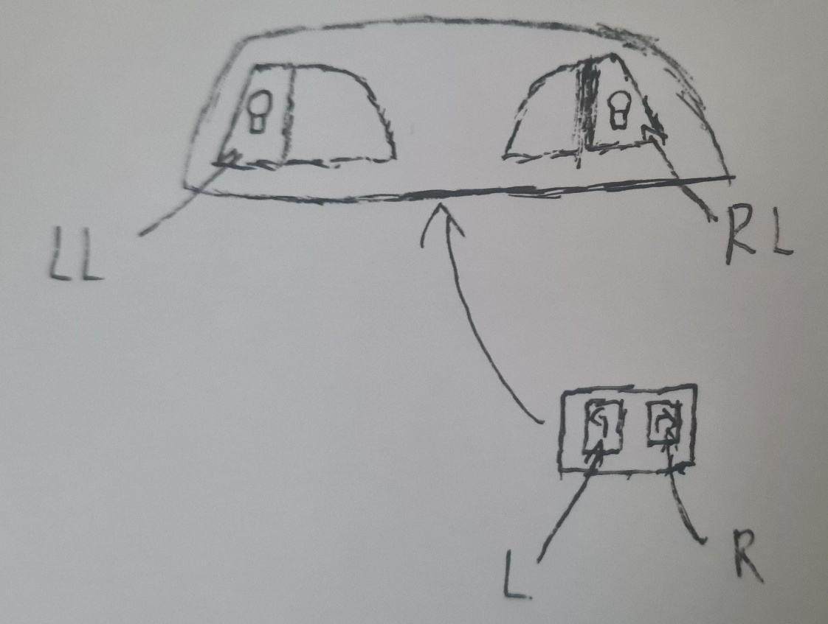

The starting phase all turn lights are off. If the left button/L button is pressed then left turn light/LL will flicker and if the right button/R is pressed then the right turn light will flicker/RL. If LL is flickering and L is pressed then LL will turn off/return to starting state and if RL is flickering and R is pressed then RL will turn off. If LL is flickering and R is pressed then LL will turn off and RL will flicker, and if RL is flickering and L is pressed then RL will turn off and LL will flicker. If at any phase both R and L are pressed then both LL and RL will flicker, and if both LL and RL are flickering then pressing any button will return it into starting state.

There are 4 phases:

1. Start state (all lights are off)
2. LL is flickering and RL is off
3. LL is off and RL is flickering
4. Both LL and RL are flickering

There are 2 inputs:

1. L (left button)
2. R (right button)

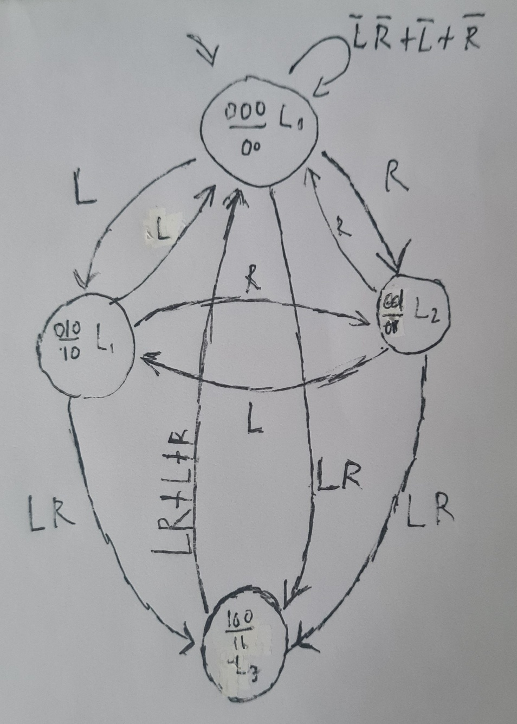

|  |  |  |  |  |  |  |
| --- | --- | --- | --- | --- | --- | --- |
| Current State | Next State | | | | Output | |
| L R  0 0 | L R  0 1 | L R  1 0 | L R  1 1 | O  1 | O  2 |
| 000 | 000 | 001 | 010 | 100 | 0 | 0 |
| 001 | 001 | 000 | 010 | 100 | 0 | 1 |
| 010 | 010 | 001 | 000 | 100 | 1 | 0 |
| 100 | 100 | 000 | 000 | 000 | 1 | 1 |